IDEATION PHASE

DEFINE THE PROBLEM STATEMENTS

|  |  |
| --- | --- |
| Date | 18 September 2022 |
| Team ID | PNT2022TMID13481 |
| Project Name | IoT Based Smart Crop Protection System For Agricultrue |
| Maximum Marks | 2 Marks |

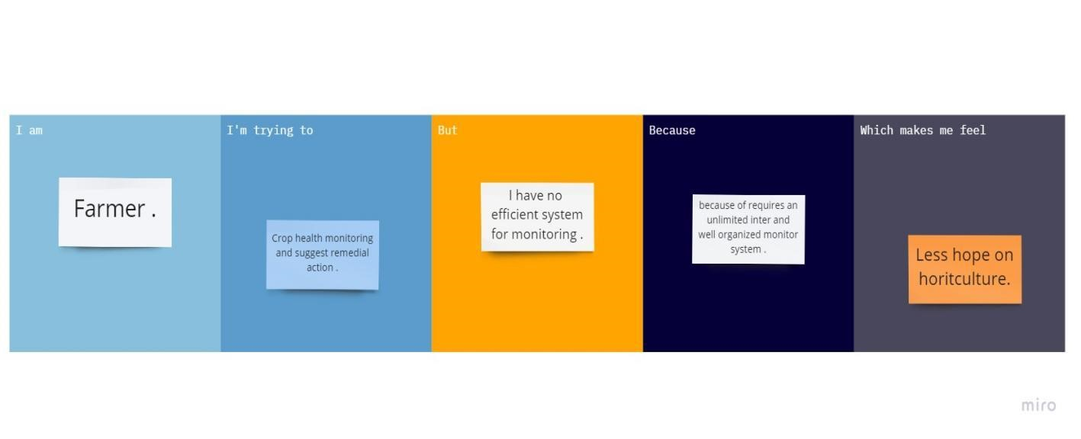

|  |  |  |  |  |  |
| --- | --- | --- | --- | --- | --- |
| Problem  Statement  (PS) | I am  (Customer) | I am trying to | But | Because | Which makes me feel |
| PS-1 | Farmer | Monitoring the growing condition | It involves risk on related equipment and understand the use of technology | Requires more  knowledge and  skills | Irritated |
| PS-2 | Farmer | Smart and precision irrigation | Climates changes to increased maintenance of channels | Purchasing and installing costs high | Suitable for mass crop protection |